[MODULE:MASTER THE CORE ELEMENT OF PERFORMANCE - SPRINT:PERFORMANCE ANALYSIS AND ACCOUNTABILITY]
INDIVIDUAL PREPARATION guide
Performance analysis and accountability

[01/05]
Introduction: Why This Sprint Matters
The Performance Analysis and Accountability sprint focuses on aligning individual and team efforts with strategic goals through structured planning, performance tracking, and accountability systems. It ensures that organizations achieve clarity, measure progress effectively, and foster continuous improvement.
Striking facts:
- Companies that implement robust accountability systems see a 20% improvement in task completion rates.
- Organizations using performance dashboards achieve 35% faster decision-making.

[02/05]
Review of Last Sprint and Learnings
(10 minutes)
Take a moment to review what you learned from the last sprint. These questions will help you crystallize your insights and think about how to apply them practically:
Write your reflections, allowing yourself to be brutally honest about what worked and what didn’t.
Start

[03/05]
Reading for This Week
(20 minutes)
"Accountability is the glue that bonds commitment to results."
[WILL CRAIG]
Imagine this reading as sharpening your sword before a battle. The better you understand and internalize these concepts, the more effective you’ll be in the challenges ahead.
Before diving into the reading, consider these questions to prime your mind
Tune-in questions
1. How do you currently measure your daily and weekly performance? Are your methods effective in driving results?
2. Why is accountability critical for achieving long-term success as a team and as an individual?
3. Imagine a dashboard showing your daily performance—what would it reveal about your focus and priorities?
Reading materials
01. BRAIN JUICE
[EXPECTED TIME: 20 MIN]
- Brain Juice: Performance Analysis and Accountability
02. DEEP DIVE
[EXPECTED TIME: 60 MIN]
[NOT INCLUDED IN THE 90-MINUTE TOTAL]
Top books
- "The 4 Disciplines of Execution" by Chris McChesney, Sean Covey, and Jim Huling
- "The Effective Executive" by Peter Drucker
- "Measure What Matters" by John Doerr
Top videos
- "Simon Sinek: Accountability in Leadership"
- "Jocko Willink: Extreme Ownership"
- "Productivity Game: The 4 Disciplines of Execution"

[04/05]
think and do
(60 minutes)
think
Reflect on the materials you will read and how they relate to your company. Consider the following:
01.
How aligned are your current tasks with your long-term goals?
02.
What changes will you make to ensure tasks are either completed or clearly analyzed for why they aren’t?
03.
How can you incorporate daily reflections into your routine for continuous learning?
do
compelte the individual tools
- Review personal task completion rates and reasons for delays.
- Identify improvement areas using tools like 5 Whys and TOC.
- Prepare insights on how departmental roles contribute to organizational goals.
- Draft an accountability checklist and proposed dashboard metrics.

[05/05]
Mind Rehearsal
(10 minutes)
Reflect on the agenda for the team sprint meeting.
When you do the mind rehearsal exercise, you should visualize the meeting in detail:
01.
What is the one process you need to master individually and as a team to improve performance?
02.
What are the biggest challenges you and the team have with performance and accountability?
03.
How can you eliminate these challenges?
Mentally rehearse your role in the meeting, focusing on where you can add the most value.
Final Tips
- Prioritize this preparation: Set aside uninterrupted time to go through this sheet.
- Use Fast Track Principles: Remember Fast Track 80/20—focus on the few critical elements that will drive most of the results. Fast Track Brutal Honesty—be honest with yourself about what you need to focus on and where you need improvement.
- Stay Engaged: The more you put into this preparation, the more you—and your team—will get out of the sprint.
Total Individual Preparation Time: 90 minutes
This guide is crafted to help you prepare thoroughly for the sprint on how to maximize your individual and team performance and accountability skills. By following these steps, you ensure that your contribution is well thought out, aligns with the Fast Track principles, and sets the stage for a successful and inspiring sprint.

[01/05]
Introduction: Why This Sprint Matters
The Performance Analysis and Accountability sprint focuses on aligning individual and team efforts with strategic goals through structured planning, performance tracking, and accountability systems. It ensures that organizations achieve clarity, measure progress effectively, and foster continuous improvement.
Striking facts:
- Companies that implement robust accountability systems see a 20% improvement in task completion rates.
- Organizations using performance dashboards achieve 35% faster decision-making.

[02/05]
Review of Last Sprint and Learnings
(10 minutes)
Take a moment to review what you learned from the last sprint. These questions will help you crystallize your insights and think about how to apply them practically:
Write your reflections, allowing yourself to be brutally honest about what worked and what didn’t.
Start

[03/05]
Reading for This Week
(20 minutes)
"Accountability is the glue that bonds commitment to results."
[WILL CRAIG]
Imagine this reading as sharpening your sword before a battle. The better you understand and internalize these concepts, the more effective you’ll be in the challenges ahead.
Before diving into the reading, consider these questions to prime your mind
Tune-in questions
1. How do you currently measure your daily and weekly performance? Are your methods effective in driving results?
2. Why is accountability critical for achieving long-term success as a team and as an individual?
3. Imagine a dashboard showing your daily performance—what would it reveal about your focus and priorities?
Reading materials
01. BRAIN JUICE
[EXPECTED TIME: 20 MIN]
- Brain Juice: Performance Analysis and Accountability
02. DEEP DIVE
[EXPECTED TIME: 60 MIN]
[NOT INCLUDED IN THE 90-MINUTE TOTAL]
Top books
- "The 4 Disciplines of Execution" by Chris McChesney, Sean Covey, and Jim Huling
- "The Effective Executive" by Peter Drucker
- "Measure What Matters" by John Doerr
Top videos
- "Simon Sinek: Accountability in Leadership"
- "Jocko Willink: Extreme Ownership"
- "Productivity Game: The 4 Disciplines of Execution"

[04/05]
think and do
(60 minutes)
think
Reflect on the materials you will read and how they relate to your company. Consider the following:
01.
How aligned are your current tasks with your long-term goals?
02.
What changes will you make to ensure tasks are either completed or clearly analyzed for why they aren’t?
03.
How can you incorporate daily reflections into your routine for continuous learning?
do
compelte the individual tools
- Review personal task completion rates and reasons for delays.
- Identify improvement areas using tools like 5 Whys and TOC.
- Prepare insights on how departmental roles contribute to organizational goals.
- Draft an accountability checklist and proposed dashboard metrics.

[05/05]
Mind Rehearsal
(10 minutes)
Reflect on the agenda for the team sprint meeting.
When you do the mind rehearsal exercise, you should visualize the meeting in detail:
01.
What is the one process you need to master individually and as a team to improve performance?
02.
What are the biggest challenges you and the team have with performance and accountability?
03.
How can you eliminate these challenges?
Mentally rehearse your role in the meeting, focusing on where you can add the most value.
Final Tips
- Prioritize this preparation: Set aside uninterrupted time to go through this sheet.
- Use Fast Track Principles: Remember Fast Track 80/20—focus on the few critical elements that will drive most of the results. Fast Track Brutal Honesty—be honest with yourself about what you need to focus on and where you need improvement.
- Stay Engaged: The more you put into this preparation, the more you—and your team—will get out of the sprint.
Total Individual Preparation Time: 90 minutes
This guide is crafted to help you prepare thoroughly for the sprint on how to maximize your individual and team performance and accountability skills. By following these steps, you ensure that your contribution is well thought out, aligns with the Fast Track principles, and sets the stage for a successful and inspiring sprint.

[MODULE:MASTER THE CORE ELEMENT OF PERFORMANCE - SPRINT:PERFORMANCE ANALYSIS AND ACCOUNTABILITY]
brain juice

[01/05]

Tune-In Questions
(10 min)

Start
[02/05]
Fast Track 80-20
Simplifying performance analysis and accountability
Performance is like a GPS for your business journey. It tells you where you are, where you're going, and whether you're on track.
- Alignment check: Are 80% of your tasks directly aligned with weekly and quarterly goals?
- Task completion: All tasks are either done or not done. No “in progress.”
- Root causes for Not Done
1. Lack of time investment.
2. Poor planning or resource gaps.
3. Capability gaps.
Key learnings
1. Task alignment
Tasks must be tied to clear objectives. Misalignment wastes energy.
2. Binary completion
Tasks are done or not done—no gray areas. This clarity drives accountability.
3. Analyzing gaps
Using tools like the 5 Whys and Theory of Constraints, identify why tasks fail.
4. Daily insights
Capture one learning each day to turn experiences into actionable wisdom.
5. Visual accountability
Dashboards provide a shared view of performance, fostering transparency and collaboration.

[03/05]
Mastering PERFORMANCE ANALYSIS AND ACCOUNTABILITY
1. Why Performance Tracking Matters
Clear performance metrics ensure every team member works on what truly drives results.
Prioritizing transforms the way teams approach work by zeroing in on a single, critical objective that outshines all others. For example, a sales team might aim to "increase monthly revenue from $100K to $200K by Q3." This clarity sharpens focus and minimizes distractions. The key is framing the WIG in actionable terms and aligning all efforts to support it. To execute, ensure every task or project is reviewed for alignment with this goal during weekly planning.
2. Task alignment
Define weekly and quarterly goals. Measure how well tasks align.
Measuring lead behaviors instead of only tracking lag results ensures progress toward goals even before final outcomes materialize. For instance, a marketing team aiming for 1,000 new leads in a quarter could track daily outreach emails or campaign launches. This approach builds momentum and keeps teams motivated through visible progress. Implement a system where lead measures are reviewed daily and celebrated weekly, reinforcing their importance.
3. Task completion tracking
Tasks are either done or not done. If not done, analyze the root cause.
Binary task completion—tasks are either done or not done—simplifies performance tracking while exposing obstacles to progress. Imagine a project manager who reviews daily tasks and finds incomplete ones tied to unclear instructions or resource shortages. This binary approach forces clarity, as reasons for delays become actionable insights. To make this practical, incorporate end-of-day reviews where team members log what was completed and reflect on lessons learned.
4. Daily reflections
Every day, mark tasks as done or not done and note one key learning.
Visual dashboards create transparency and accountability, allowing teams to see their progress at a glance. For example, a product development team tracking new feature rollouts could display milestones, tasks, and deadlines visually. Dashboards not only motivate but also pinpoint bottlenecks quickly. Make this actionable by updating dashboards weekly and ensuring they are accessible to everyone involved.
5. Weekly analysis
Every Monday, review performance dashboards to pinpoint issues and improve.
Weekly accountability meetings drive results by creating a forum to discuss goals, progress, and challenges. A retail team, for example, might meet every Monday to review last week’s sales numbers and refine strategies. This consistent rhythm ensures everyone stays aligned and proactive. To enhance effectiveness, use a standard agenda focusing on performance data, problem-solving, and next steps.
6. Accountability practices
Establish clear accountability and consequences policies using the provided checklist.
Intentional focus stems from a clear schedule of priorities, supported by personal operating systems (POS) to enforce habits. A CEO balancing long-term strategy with daily operations might allocate mornings exclusively for strategic tasks. This structure reduces decision fatigue and enhances productivity. Start small by scheduling recurring time blocks for high-priority work and resisting interruptions during those windows.
7. Tools and techniques
Apply 5 whys to find root causes. Use the theory of constraints to optimize workflows.
Root cause analysis, like the 5 Whys, uncovers underlying reasons for task non-completion, driving meaningful improvements. If a software engineer misses a deadline, digging deeper might reveal resource gaps or unclear project specifications. This process ensures solutions address real problems, not just symptoms. Make it habitual by adding a quick root cause review for all delayed tasks during weekly meetings.
8. Team dashboards
Design dashboards to visualize performance data, making it accessible and actionable.
Effective time management is about mastering your calendar to make the most of limited hours. For instance, an executive who blocks mornings for deep work and afternoons for meetings achieves more impactful results. Recording how time is spent exposes inefficiencies, leading to better planning. Implement this by logging activities for a week and revising schedules to prioritize uninterrupted focus time.
9. Consequences and accountability
Develop a policy where accountability is paired with clear consequences.
Leveraging individual and team strengths amplifies results by matching tasks to capabilities. A marketing campaign requiring creativity and analytical precision might pair a creative strategist with a data analyst. This alignment not only enhances efficiency but also boosts team morale. Encourage managers to reassess assignments regularly, ensuring everyone’s strengths are fully utilized.
10. Continuous improvement
Weekly improvements ensure alignment, efficiency, and growth.
Shared accountability builds stronger teams by ensuring everyone understands their role in collective success. A customer service team might create a checklist for resolving complaints within 48 hours, with each member responsible for a specific metric. Shared accountability creates a culture of reliability and pride. Formalize this by developing a team charter that defines roles, expectations, and shared goals.

[04/05]

reflection time
(10 min)

Start
[05/05]
Final Thought
Summarize your learning in one sentence:
- "Clarity in performance tracking and accountability is the foundation of consistent success—what will I do differently starting today?"

[MODULE:MASTER THE CORE ELEMENT OF PERFORMANCE - SPRINT:PERFORMANCE ANALYSIS AND ACCOUNTABILITY]
Planning and Performance Monitoring Process
Tool explanation and guide – FOR REVIEW ONLY
[01/05]
introduction
In the fast-paced world of business, the ability to set clear goals, align priorities, and continuously improve is the cornerstone of success. The Fast Track Planning and Performance Monitoring Process provides a comprehensive methodology to align efforts, monitor progress, and drive measurable results at all levels of the organization. This guide outlines a practical framework for achieving excellence through clarity, focus, and systematic execution.
[02/05]
TOOL PREVIEW
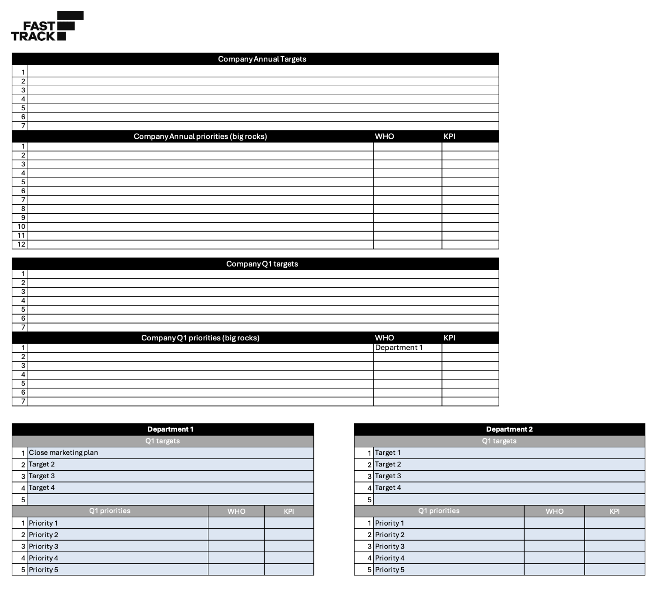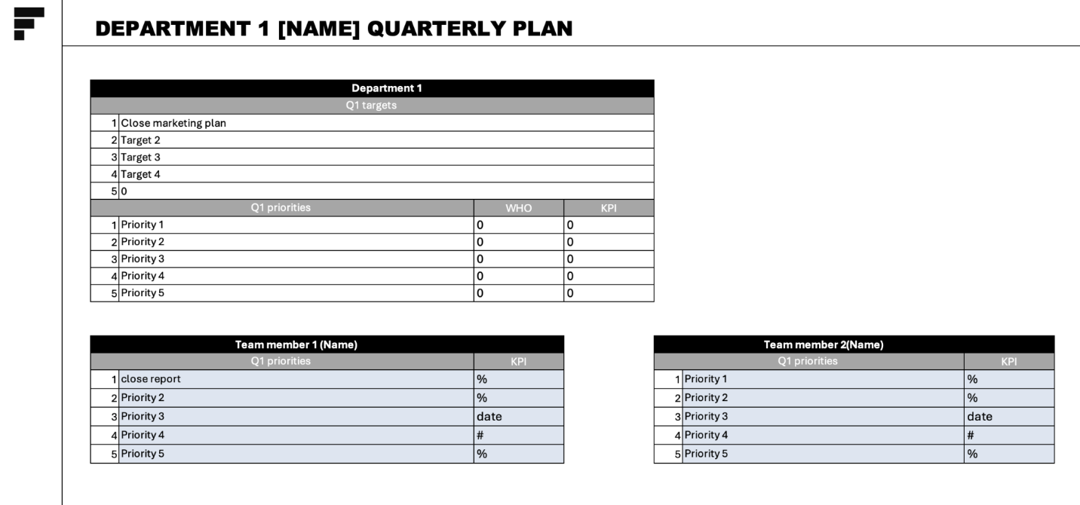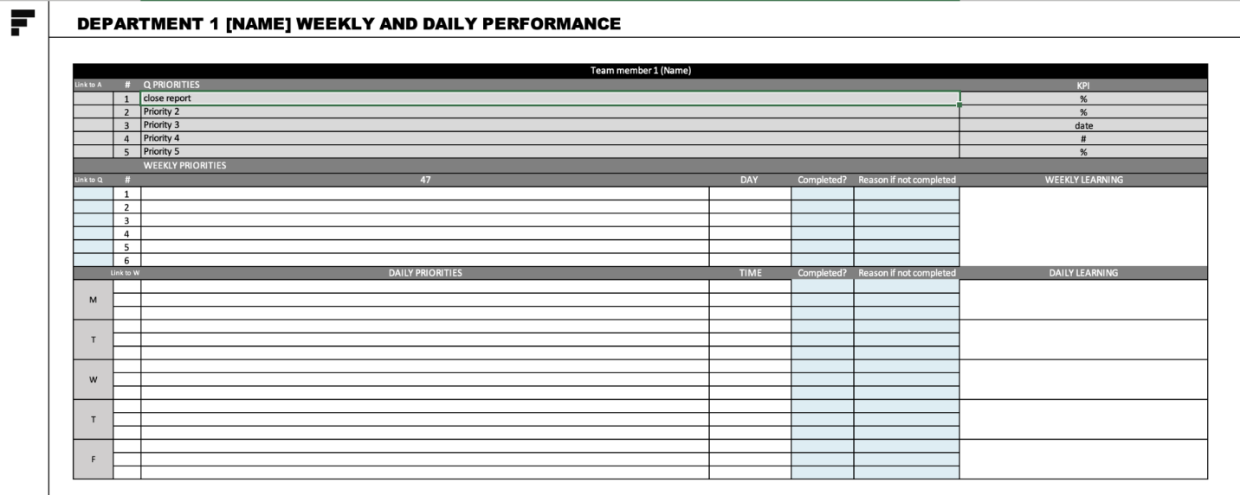
[03/05]
Purpose
The Fast Track methodology ensures that goals are clearly defined, priorities are focused, and results are continuously monitored. This process integrates cutting-edge principles like the 80/20 rule, Theory of Constraints (TOC), and simplicity to optimize performance and ensure sustainable growth.
Positive outcomes
- Clear alignment of individual and team priorities with strategic goals.
- Enhanced focus on high-impact activities.
- Data-driven insights for continuous improvement.
- A culture of accountability and transparency.
[04/05]
Step-by-Step Instructions
1. Goal setting, priority management, and execution
Numeric Goals
Define five specific, measurable goals for the year. Identify the most critical goal and establish countermeasures to prevent over-focus.
- Example: "Increase revenue by 20%, but maintain gross margins above 40%."
Brainstorming and Prioritization: Generate project ideas, rank them using the 80/20 rule and Impact-Easy matrix, and select the top five projects per goal.
Execution Tip: Use brainstorming sessions to identify high-impact actions for each goal.
Quarterly Breakdown: Break annual priorities into quarterly deliverables with one owner and one KPI for each target.
Checklist:
- Are annual goals broken into smaller, quarterly priorities?
- Does each quarterly goal have a clear owner and measurable KPI?
2. Performance measurement and analysis
Task Tracking
Measure task completion daily and weekly, focusing on outcomes rather than effort.
- Example: Use a simple system to log whether tasks are “done” or “not done” and document reasons for delays.
Visualization: Implement dashboards to monitor performance metrics for individuals, teams, and departments.
Checklist:
- Is there a system in place to track task completion rates?
- Are performance dashboards updated weekly and reviewed?
3. Data analysis and strategic insights
Pattern Identification
Analyze team and individual data trends over the last three months to identify areas for improvement.
- Example: Use AI tools to spot recurring bottlenecks in project workflows.
Risk Assessment: Identify goals in "unique danger" and evaluate their impact on overall achievement.
Checklist:
- Are patterns of performance and bottlenecks documented?
- Are high-risk goals prioritized for immediate intervention?
4. Recommendations for improvement
Translate insights into a WHO, WHAT, WHEN document for implementation.
- Example: Focus efforts on the top 2-3 bottlenecks identified by TOC and prioritize tasks using the 80/20 rule.
Continuous monitoring: Reassess priorities and adjust plans quarterly based on progress and emerging challenges.
Checklist:
- Are recommendations translated into specific, actionable steps?
- Are adjustments based on TOC and data-driven insights?
The Fast Track Planning and Performance Monitoring Process equips organizations with the tools to excel by focusing on the right goals, tracking performance, and driving continuous improvement. By following this systematic approach, teams can unlock their full potential and achieve sustained success.
[05/05]
cHecklist
Goal setting and priority management
- Are numeric goals for the year clearly defined and measurable?
- Have priorities been ranked and broken into smaller, manageable deliverables?
- Is there a countermeasure in place to balance focus on critical goals?
Performance monitoring
- Is task completion tracked daily and weekly?
- Are reasons for missed tasks documented and analyzed?
- Are dashboards used for team-wide performance visualization?
Data analysis
- Are patterns of underperformance and success identified through data analysis?
- Are improvement steps clearly outlined and prioritized?
Implementation
- Are improvement plans documented and assigned to specific owners?
- Are progress reviews conducted quarterly and adjustments made proactively?

[MODULE:MASTER THE CORE ELEMENT OF PERFORMANCE - SPRINT:PERFORMANCE ANALYSIS AND ACCOUNTABILITY]
ACCOUNTABILITY
AND CONSEQUENCES
Tool explanation and guide – FOR REVIEW ONLY
[01/06]
introduction
Imagine a team where every player knows their role and the scoreboard is visible to all. They understand the stakes of success and failure. This is the power of a well-structured accountability and consequences system: it aligns behaviors with goals and ensures every individual contributes meaningfully to collective success.
[02/06]
TOOL PREVIEW
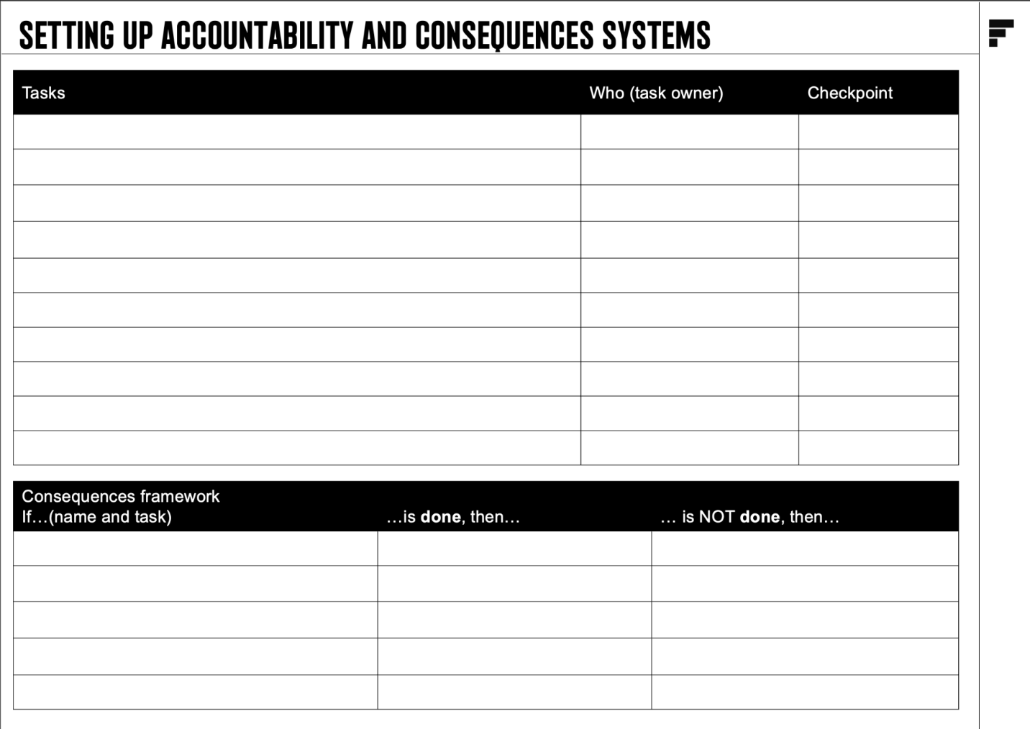
[03/06]
Purpose
The Fast Track Accountability and Consequences System ensures clear ownership of tasks, consistent follow-up, and structured consequences for both success and failure. It fosters a culture where performance is transparent, expectations are clear, and actions align with strategic goals.
Positive outcomes
- Improves clarity of roles and responsibilities.
- Builds trust through transparent and fair consequences.
- Aligns individual actions with organizational goals.
- Drives performance improvement by reinforcing accountability.
[04/06]
Step-by-Step Instructions
1. Define expectations
Clearly articulate roles, tasks, and goals for each individual and team.
- Question: Are responsibilities specific and measurable?
- Example: A sales manager must close $50K in monthly revenue.
2. Assign ownership
Ensure each task has a single accountable owner.
- Question: Who is ultimately responsible for this deliverable?
- Example: Assign one team member to oversee weekly performance reviews.
3. Set checkpoints
Establish regular review points to monitor progress.
- Question: When and how will performance be evaluated?
- Example: Schedule a weekly Monday meeting to review task completion.
4. Create consequences framework
Define rewards for success and corrective actions for failure.
- Question: What happens when goals are met or missed?
- Example: Bonus for exceeding KPIs; training sessions for underperformance.
5. Implement dashboards
Use visual tools to track and display accountability metrics.
- Question: Can everyone see the team’s progress in real-time?
- Example: A dashboard showing tasks completed, missed, and their reasons.
6. Foster transparency
Ensure everyone understands the system and its implications.
- Question: Are all team members aware of the expectations and consequences?
- Example: Share a one-pager summarizing accountability policies during onboarding.
7. Review and adjust
Regularly revisit the system to ensure alignment with goals and team dynamics.
- Question: Is the system driving the intended behaviors?
- Example: Quarterly reviews to refine accountability practices.
[05/06]

Main Challenges and Solutions
1. Lack of Buy-In
- Example: Resistance to consequences
- Solution: Involve the team in defining the system.
2. Inconsistent Follow-Up
- Example: Managers skipping reviews
- Solution: Automate reminders for checkpoints.
3. Ambiguous Responsibilities
- Example: Tasks with unclear owners
- Solution: Use role charters to clarify ownership.
[06/06]
checklist
1. Define expectations
- Are responsibilities clearly defined?
- Are tasks measurable with specific deadlines?
- Have all team members reviewed their expectations?
2. Assign ownership
- Does every task have a single accountable owner?
- Are there no overlaps in ownership?
- Is each owner empowered to make decisions?
3. Set checkpoints
- Are checkpoints scheduled regularly?
- Do reviews align with task deadlines?
- Are methods for evaluating progress standardized?
4. Create consequences framework
- Are rewards meaningful and tied to performance?
- Are corrective actions fair and constructive?
- Is the framework transparent and documented?
5. Implement dashboards
- Are key metrics visible to everyone?
- Does the dashboard show task completion rates?
- Can the dashboard highlight recurring issues?
6. Foster transparency
- Are all policies communicated effectively?
- Do team members understand the system’s goals?
- Is there a process to address concerns about fairness?
7. Review and adjust
- Is the system evaluated at least quarterly?

[MODULE:MASTER THE CORE ELEMENT OF PERFORMANCE - SPRINT:PERFORMANCE ANALYSIS AND ACCOUNTABILITY]
THE 5 WHYS
Tool explanation and guide – FOR REVIEW ONLY
[01/06]
introduction
Picture a curious child asking, “Why?” over and over until they truly understand a concept. This relentless questioning unravels the layers of assumptions and reveals the core truth. The 5 Whys tool operates the same way, guiding you to uncover the root cause of a problem and ensuring your solutions address the real issue.
[02/06]
TOOL PREVIEW
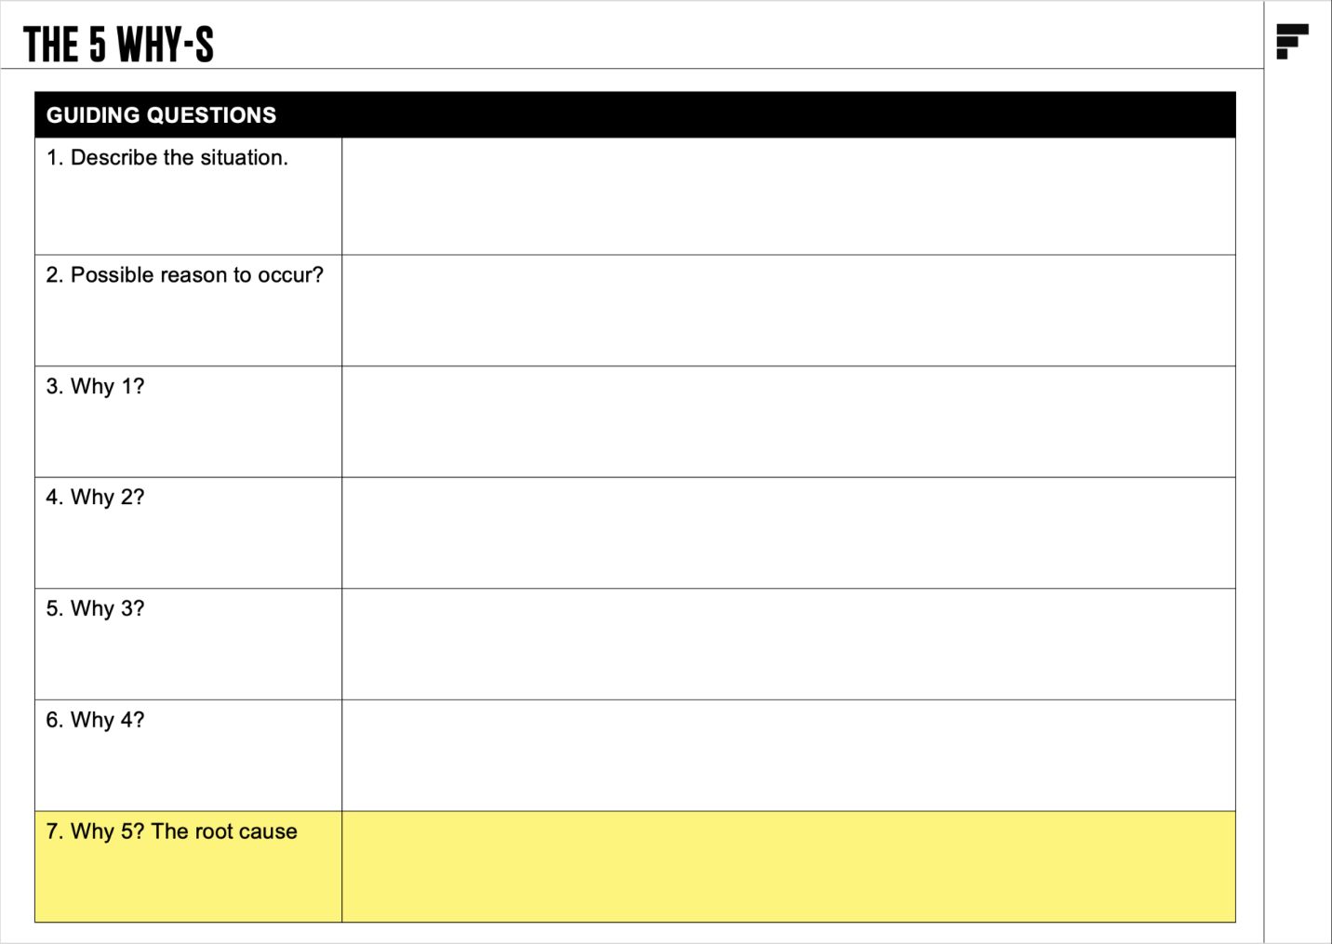
[03/06]
Purpose
The 5 Whys is a simple yet powerful root cause analysis method developed by Toyota. It uses iterative questioning to drill down into a problem’s core cause. By addressing the root rather than the symptoms, you save time, resources, and avoid recurring issues.
Positive outcomes
- Eliminates surface-level solutions and focuses on true causes.
- Reduces recurring problems through systemic changes.
- Enhances decision-making with clarity and insight.
- Encourages a culture of curiosity and continuous improvement.
[04/06]
Step-by-Step Instructions
1. Define the problem
Write a clear and concise problem statement.
- Question: What is the specific issue we’re experiencing?
- Example: "Our delivery times are consistently delayed."
2. Ask ‘Why?’ the first time
Identify the immediate reason for the problem.
- Question: Why is the delivery delayed?
- Answer: "The orders are not leaving the warehouse on time
3. Repeat ‘Why?’ up to five times
Continue asking why until you uncover the root cause.
Example:
- Why aren’t orders leaving on time? “Packaging takes too long.”
- Why does packaging take too long? “We don’t have enough staff.”
- Why don’t we have enough staff? “High turnover rates.”
- Why is turnover high? “Inadequate training for new hires.”
4. Address the root cause
Develop a solution that targets the root cause identified.
- Question: What can we do to reduce turnover and improve training?
- Answer: "Implement a structured onboarding program and mentorship."
5. Validate and monitor
Test your solution and observe its impact over time.
- Question: Has this solution eliminated the issue?
- Example: Track delivery times and employee retention metrics.
[05/06]

Main Challenges and Solutions
1. Stopping too soon
- Example: Only identifying symptoms
- Solution: Always push to five iterations.
Biased answers
- Example: Favoring convenient explanations
- Solution: Include cross-functional perspectives.
3. Overgeneralized root causes
- Example: “Lack of resources” as a generic answer
- Solution: Be specific and actionable.
[06/06]

f.a.q. and answers
1. Do I always need to ask ‘Why?’ five times?
Not necessarily. Stop when the root cause becomes evident, but ensure it is specific and actionable.
2. Can this be used for every type of problem?
It’s best for recurring or process-related issues. For highly complex problems, pair it with other tools.
What if multiple root causes emerge?
Address them one by one, prioritizing the most impactful issue.

[MODULE:MASTER THE CORE ELEMENT OF PERFORMANCE - SPRINT:PERFORMANCE ANALYSIS AND ACCOUNTABILITY]
the 80/20 principle
Tool explanation and guide – FOR REVIEW ONLY
[01/06]
introduction
Imagine running a factory where 20% of your machines produce 80% of your revenue. You’d focus all your efforts on optimizing those few machines, right? That’s the power of the 80/20 Principle, also known as the Pareto Principle. It reveals that a small percentage of inputs often drive the majority of results, empowering you to focus on what truly matters.
[02/06]
TOOL PREVIEW
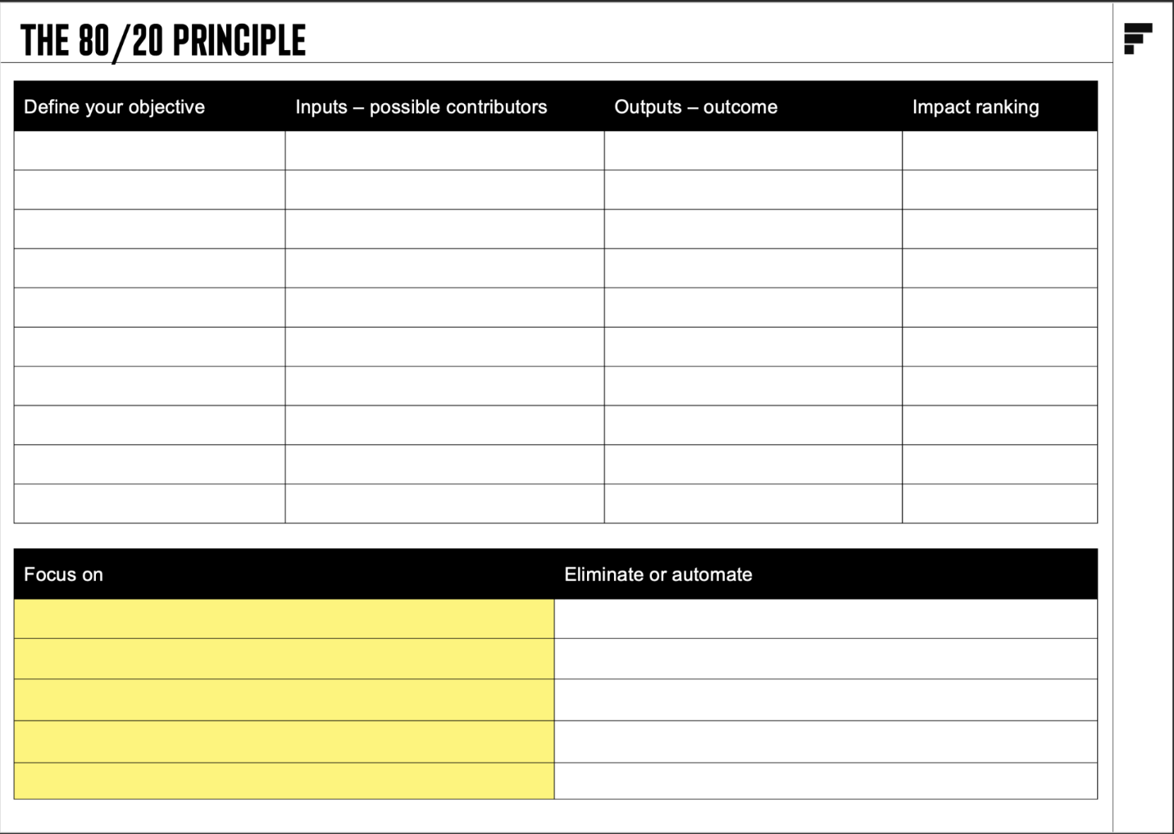
[03/06]
Purpose
The 80/20 Principle is a decision-making framework that identifies the highest-impact activities, helping you prioritize your efforts where they matter most. Originating from Italian economist Vilfredo Pareto, this principle has been widely applied in business, productivity, and strategy.
Positive outcomes
- Maximizes resource allocation for high-impact results.
- Reduces wasted effort on low-value activities.
- Clarified priorities for faster decision-making.
- Exponential growth by focusing on key areas.
[04/06]
Step-by-Step Instructions
1. Define Your Objective
Identify the goal or area where the 80/20 analysis will be applied.
- Question: What result are we aiming to achieve?
- Example: Increase sales revenue.
2. Identify the Inputs and Outputs
List all possible contributors (inputs) to the outcome (outputs).
- Question: What are all the factors contributing to this result?
- Example: Customer segments, sales channels, and product lines.
3. Rank by Impact
Use data to rank inputs by their contribution to the desired outcome.
- Question: Which inputs deliver the most significant results?
- Example: 80% of sales come from 20% of customers.
4. Focus on the Vital Few
Prioritize the top-performing inputs for action and improvement.
- Question: How can we enhance these high-impact inputs?
- Example: Offer loyalty programs for top customers.
5. Eliminate or Automate the Trivial Many:
Reduce or delegate low-impact activities to save time and resources.
- Question: What activities can we stop or automate?
- Example: Automate invoicing for low-spending clients.
[05/06]

Main Challenges and Solutions
1. Data overload
- Example: Too many inputs to analyze
- Solution: Start with available data and refine.
2. Resistance to focus
- Example: Teams reluctant to drop low-impact tasks
- Solution: Communicate benefits clearly.
3. Misidentification of inputs
- Example: Relying on assumptions
- Solution: Validate findings with data.
[06/06]

f.a.q. and answers
1. Does 80/20 apply universally?
Yes, while the ratio may vary, the principle holds across industries and functions.
2. Can low-impact activities ever be important?
Occasionally. Focus on the 80/20 inputs but monitor low-impact areas for risks.
3. What if I can’t identify the 20%?
Use data analysis or brainstorming sessions with key stakeholders to find patterns.

[MODULE:MASTER THE CORE ELEMENT OF PERFORMANCE - SPRINT:PERFORMANCE ANALYSIS AND ACCOUNTABILITY]
brainstorming and
impact easy
Tool explanation and guide – FOR REVIEW ONLY
[01/06]
introduction
Imagine a gold miner sorting through dirt to find nuggets. Brainstorming generates a wide range of ideas, like sifting for gold, while the Impact-Easy Matrix acts as the miner’s pan, quickly sorting high-value ideas from distractions. This dual approach ensures your team prioritizes solutions that deliver maximum impact with minimum effort.
[02/06]
TOOL PREVIEW
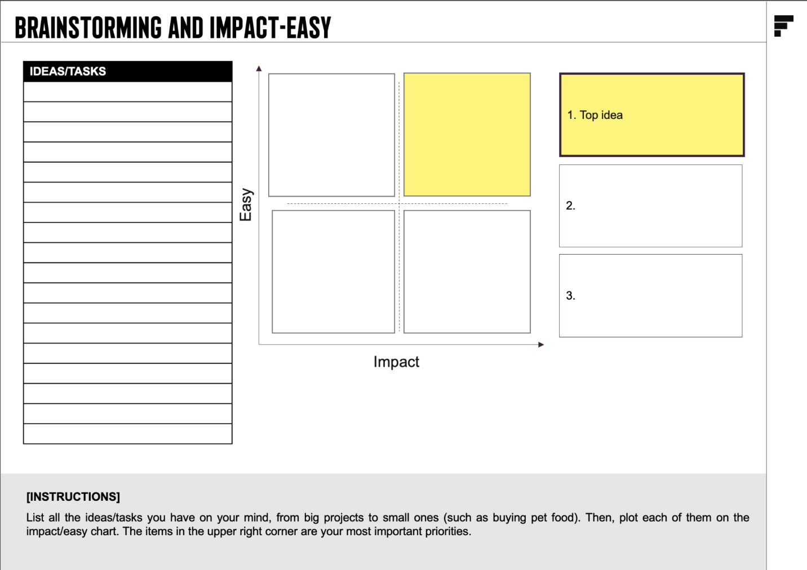
[03/06]
Purpose
Brainstorming fosters creative thinking, encouraging teams to generate as many ideas as possible without judgment. The Impact-Easy Matrix then evaluates those ideas based on their potential impact and implementation effort, ensuring resources are focused where they’ll have the greatest return.
Positive outcomes
- Unlocks team creativity while avoiding analysis paralysis.
- Identifies high-value, low-effort solutions to problems.
- Builds alignment around actionable priorities.
- Speeds up decision-making and execution.
[04/06]
Step-by-Step Instructions
brainstorming
1. Set a clear objective
Define the problem or opportunity you’re addressing.
- Question: What do we want to solve or achieve?
- Example: “How can we increase customer engagement?”
2. Generate Ideas
Encourage participants to list as many ideas as possible without judgment.
- Question: What are all the possible ways to solve this problem?
- Example: Improve email personalization, create a loyalty program, or host live webinars.
3. Cluster and Refine
Group similar ideas together to reduce redundancy and clarify options.
- Question: Which ideas overlap, and how can they be combined?
- Example: Combine webinar ideas into a larger customer education initiative.
impact easy
4. Rate each idea
Score ideas on a scale of 1-10 for both impact (value delivered) and ease (effort required).
- Question: How valuable is this idea, and how easy is it to implement?
- Example: Email personalization might score 9 for ease and 7 for impact.
5. Plot on the matrix
Place each idea into one of four quadrants:
- High Impact, Low Effort: Prioritize these.
High Impact, High Effort: Plan and allocate resources.
Low Impact, Low Effort: Address opportunistically.
Low Impact, High Effort: Avoid or defer.
- Question: Which ideas fall into the “quick wins” category?
6. Decide and act
Focus on ideas in the High Impact, Low Effort quadrant first, then create action plans for others.
- Example: Launch an email personalization campaign as a quick win while planning a loyalty program.
[05/06]

Main Challenges and Solutions
1. Overwhelming Idea Volume
- Example: Too many ideas with unclear priorities
- Solution: Use clustering and scoring to focus.
2. Subjective Scoring
- Example: Team members rate ideas inconsistently
- Solution: Agree on clear criteria for impact and ease.
3. Analysis Paralysis
- Example: Debates delay decision-making
- Solution: Set strict time limits for evaluation.
[06/06]

f.a.q. and answers
What if two ideas score equally in the matrix?
Choose the idea with faster implementation or higher alignment with strategic goals.
2. How do I ensure brainstorming includes innovative ideas?
Use prompts like “What would we do if resources weren’t a constraint?” to spark creativity.
3. Can I use this matrix for long-term projects?
Yes, but revisit scores periodically to adjust for changing circumstances.

[MODULE:MASTER THE CORE ELEMENT OF PERFORMANCE - SPRINT:PERFORMANCE ANALYSIS AND ACCOUNTABILITY]
THE THEORY OF CONSTRAINTS
Tool explanation and guide – FOR REVIEW ONLY
[01/06]
introduction
Imagine a powerful river flowing toward a dam. The water struggles to pass through a single narrow opening, causing a bottleneck that limits the flow. When that bottleneck is cleared, the river flows freely, unlocking immense power downstream. This is the essence of the Theory of Constraints: identifying and resolving the single most critical bottleneck that hinders your system's performance.
[02/06]
TOOL PREVIEW
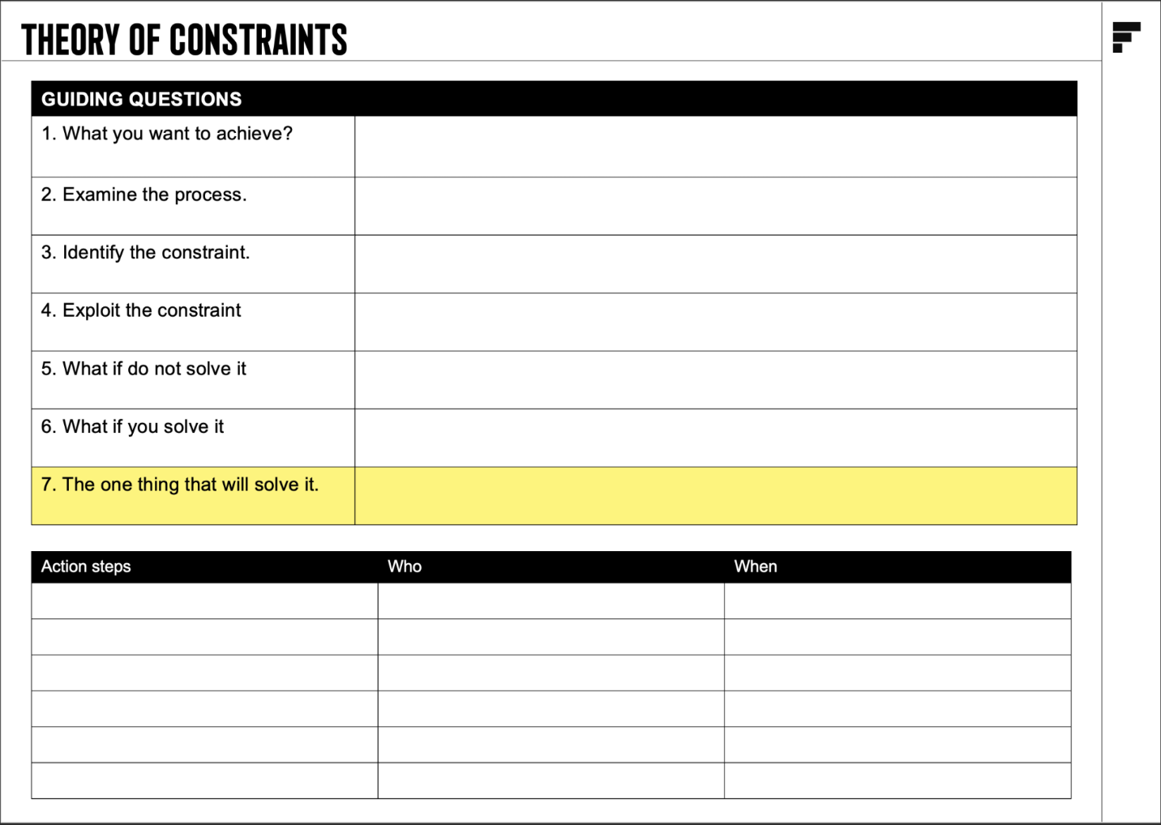
[03/06]
Purpose
The Theory of Constraints is a systematic approach to identify the most significant barrier to achieving a goal and then systematically improve it until it is no longer the limiting factor. Originating from Dr. Eliyahu Goldratt's groundbreaking work, this method empowers teams to unlock their potential by focusing on what matters most.
Positive outcomes
- Boosts efficiency by focusing on high-impact areas.
- Increases throughput by resolving key blockages.
- Enhances team alignment with a shared focus.
- Results in faster, more sustainable performance improvements.
[04/06]
Step-by-Step Instructions
1. Identify the constraint
Examine your processes to pinpoint the step that limits the entire system’s performance.
- Question: Which part of the system slows everything else down?
- Example: A manufacturing assembly line where one station consistently causes delays.
2. Exploit the constraint
Maximize the efficiency of the identified bottleneck without significant investment.
- Question: How can we make this step work at its full capacity?
- Example: Adjust work schedules to ensure the constrained station operates continuously.
3. Subordinate other processes
Align all other steps to support the constraint.
- Question: How can the rest of the system synchronize with the bottleneck’s pace?
- Example: Reduce the workload on subsequent steps to avoid overwhelming the bottleneck.
4. Elevate the constraint
If the constraint remains, consider investments to expand its capacity.
- Question: What resources or innovations can remove this limitation?
- Example: Upgrade machinery at the bottleneck station to increase its speed.
5. Repeat the process
Once a constraint is resolved, another will emerge. Continuously improve by repeating these steps.
[05/06]

Main Challenges and Solutions
1. Resistance to change
- Example: Staff reluctant to adjust processes
- Solution: Highlight quick wins to gain buy-in.
2. Misidentification of constraints
- Example: Focusing on minor inefficiencies
- Solution: Use data analysis to validate the constraint.
3. Overloading the bottleneck
- Example: Assigning too many resources prematurely
- Solution: Balance workload and monitor closely.
[06/06]

f.a.q. and answers
1. How do I know I’ve found the real constraint?
Look for the point where work piles up or delays occur frequently. Validate with data before taking action.
2. Can constraints change over time?
Yes, resolving one bottleneck often reveals another. Continuous improvement is key.
3. What if I can’t change the constraint?
Focus on exploiting and subordinating. Often, small adjustments yield significant results.

[MODULE:MASTER THE CORE ELEMENT OF PERFORMANCE - SPRINT:PERFORMANCE ANALYSIS AND ACCOUNTABILITY]

PROCESS TOOLS
Tools
- The 5 Why's
- The 80/20 principle
- Brainstorming and Impact-easy
- Accountability and consequences
[MODULE:MASTER THE CORE ELEMENT OF PERFORMANCE - SPRINT:PERFORMANCE ANALYSIS AND ACCOUNTABILITY]
TEAM MEETING PREPARATION GUIDE

[01/06]
meeting Purpose
This meeting is critical to establishing two foundational systems that will drive your team’s success:
1. Performance analysis system
- A robust framework to measure individual and team outputs effectively.
2. Accountability and consequences system
- A structured plan ensuring clarity in roles, consistent follow-through, and clear repercussions for actions.
By the end of this meeting, you will have clear agreements on who, what, when, and how for both systems, ensuring alignment and readiness for immediate implementation.

[02/06]
What to Prepare
1. Review
- The Sprint Brain Juice document on Performance analysis and accountability.
- Fast Track guides on the Theory of Constraints and 5 Whys for root cause analysis.
- The Accountability and Consequences framework.
2. Complete individual tools
- Individual reflection on tasks completed or not completed last week, reasons for gaps, and suggested improvements.
- Draft a proposed accountability checklist for your area of responsibility.
3. Discussion points
- Come prepared with insights on how your role impacts performance metrics.
- Suggestions for key accountability practices specific to your function.

[03/06]
Pre-Mortem Instructions
Potential issues
- Lack of clarity in defining tasks or metrics.
- Resistance to accountability measures.
- Overestimation of resources or under-allocation of ownership.
Preventive strategies
- Focus on simplicity when defining metrics and tasks.
- Facilitate open discussion to address concerns about accountability.
- Use real data to back decisions on task assignments and consequences.

[04/06]
Meeting Agenda
team meeting
Total duration: 60 minutes
1. Objective setting (5 min)
Brief recap of sprint goals and the meeting's objectives.
2. Setting up the performance analysis system (25 min)
- Review the proposed system structure (tasks done/not done, reasons for gaps, and improvement commitments).
- Discuss individual and team-level dashboards.
- Agree on the timeline and ownership for setup.
3. Planning the accountability and consequences system (25 min)
- Review the Accountability Checklist and key practices.
- Align on the consequences framework (rewards for success, corrective actions for gaps).
- Assign roles for implementing and monitoring the system
4. Action plan and closing (5 min)
- Confirm “Who, What, When” for all agreed actions.
- Address final questions and summarize key takeaways.
[05/06]
checklist
Setting up the performance analysis system
- Are the tasks and metrics defined clearly for all team members?
- Is there a binary approach (done/not done) to task evaluation?
- Are dashboards designed to track individual and team metrics?
Accountability and consequences system:
- Are roles and responsibilities for accountability clearly assigned?
- Is the consequences framework transparent and fair?
- Are timelines for setup and execution realistic and agreed upon?
[06/06]
Final Reminders
- Focus on precision: Avoid vague metrics or roles—everything must be specific and measurable.
- Engage fully: Every participant’s input is critical for success.
- Follow-up: Ensure all pre-meeting preparation is complete to maximize productivity during discussions.
[MODULE:MASTER THE CORE ELEMENT OF PERFORMANCE - SPRINT:PERFORMANCE ANALYSIS AND ACCOUNTABILITY]

TEAM TOOLS
Tools
- Setting Up the Performance Analysis System
- Planning the Accountability and Consequences System

OPEN TOOL
Deadline for completion Friday, 23.05.2025

Expect the Fast Track feedback by Wednesday, 28.05.2025

